COLLEGE NAME | SEGi College Subang Jaya
PROGRAMME NAME | Certificate In Information Technology (CIT)
MODULE NAME | COMPUTER ARCHITECTURE FUNDAMENTAL |  | MODUL  E CODE |  | CIT 1243
 |  |  | SEMESTER |  | SEPT – DEC 2025
MODULE LEADER | Ms. Norizan binti Johari |  | ASSESSMENT TYPE |  | Assignment  (50%)
LECTURER NAME | Ms.Mastura Binti Md Saad
STUDENT’S DECLARATION | I hereby certify that this assignment is my own work and where materials have been used from other resources, they have been properly acknowledged. I also understand that I will face the possibility of failing the module if the content of this assignment is plagiarized.  STUDENT’S ID STUDENT NAME  SCSJ2401125 Livingstone
OUTCOME(S)  / ASSESSMENT CRITERIA COVERED | CLO1: Identify hardware, software and network components and the subsystems used in a computer system (C1, PLO1)  CLO2: Identify interconnection between hardware, software and network to create a computer system (C2, PLO2)  CLO3: Apply an appropriate architecture that reflects the computer system (C3, PLO3)
RELEASE DATE | 31 OCT 2025 | SUBMISSION DUE DATE |  | 20 NOV 2025 | MARKS OBTAINED
DATE RECEIVED |  | MARKER’S NAME

Table of Contents
Introduction 2
Evolution of Digital Computers, Their Basic Structures, and How They Operate 2
Concepts of Logic Circuits and Logic Gate Design 4
Addressing Methods 5
Importance of Internal Memory, External Memory, Virtual Memory, and Cache Memory 6
Conclusion 8
References 9

Introduction
The fast development of technology has altered computers from large mechanical devices into small digital machines that govern nearly all aspects of human life. Understanding computer architecture is important in underpinning how these systems function. Computer architecture is the design of a computer system, specifically its components, how they interface with each other, and how information flows through the system. This report discusses four general topics involved in the foundational study of computer architecture. These include the history and structure of modern digital computers, the idea and construction of logic circuits, the practices of addressing in computer systems, and various types of memory—i.e., internal, external, virtual and cache memory. Each of these aspects explains how modern computers are able to preform tasks in an effectively and safely

Evolution of Digital Computers, Their Basic Structures, and How They Operate
Digital computers have developed over several generations, innovative technological breakthroughs that set each generation apart from others. The first generation of computers came into existence in the 1940s and early 1950s, and these machines used vacuum tubes to control the circuits and magnetic drums to store memory. The first generation computers were enormous, required a significant amount of electricity, and generated a fair amount of heat. Even with all of the limitations of the first computers, they provided the foundation for researchers and engineers to build upon to reach modern computing. The ENIAC and UNIVAC I are the two most notable examples from this era. Programs were written using machine language and were implemented using switches and punched cards, which made the terminals difficult to operate.The second generation of computers emerged in the late 1950s with transistors instead of vacuum tubes. Transistors were smaller, faster than tubes, and used less energy, which contributed to making computers more reliable. The second generation also saw the introduction of magnetic core memory and higher-level programming languages like FORTRAN and COBOL, which made them easier to use and commercially successful. The IBM 1401 and PDP-1 are two of the more recognizable systems in the second generation of computers. The 1960s saw the emergence of the third generation of computers, characterized by advances in integrated circuits (ICs). An integrated circuit combines many transistors, resistors, and capacitors on a single chip that enormously increased speed and lowered costs. Computers became smaller, faster, and cheaper. Operating systems were developed that allowed several programs to run at the same time. The IBM System/360 was one of the most significant systems of this generation, which shaped the design of future computer systems for decades to come.The fourth generation of computers began in the 1970s and continues to shape computers today. This age is defined by the invention of the microprocessor, which hosted the entire central processing unit (CPU) on one silicon chip. The first commercially available microprocessor debuted in 1971, the Intel 4004. Later generations of microprocessors, such as Intel's Pentium and Core series became the focus of personal computer design. The personal computer also materialized in this age, which brought computing to individuals, schools, and small businesses. The fifth generation of computers is the present stage in the evolution of technology. These computers now operate with more powerful microprocessor technology, in combination with artificial intelligence (AI), quantum computing, and cloud computing. They also are designed to be self-learning, conduct data analyses, and make decisions. Today's devices like smartphones, tablets, and high-end servers show that computing power can be both incredibly powerful and portable at the same time.The basic digital computer is built on the architecture proposed by mathematician John Von Neumann in 1945, known simply as the Von Neumann architecture. The architecture essentially has four main functions: the CPU (central processing unit), a memory unit, input and output (I/O) devices, and a system bus. The CPU is often referred to as the brain, and it performs the arithmetic and logical operations of a computer inside its arithmetic logic unit (ALU). The control unit (CU) is responsible for directing the computer execution of instructions to ensure that data flows accurately between the CPU, memory, and I/O devices. The memory unit is designed to temporarily store data and the instructions necessary to perform processing. I/O devices are involved in inputting and outputting data between the computer hardware and the outside world. The system bus connects the components, allowing communication between the components through data, address, and control lines. Computers function according to a specific cycle called the fetch–decode–execute cycle. In the fetch phase, the CPU retrieves the instruction from memory; during the decode phase, the control unit decodes the instruction to determine what operation is needed; in the execute phase, the CPU executes the operation using the ALU and then stores the information in a register or back in memory. This process occurs continuously and at incredible speed, with today's processors able to execute billions of instructions in a second. For example, as a user, when you perform an addition operation, the CPU fetches the "add" instruction from main memory, decodes the instruction, executes the addition, and stores the information all in a tiny fraction of a second. How well this process happens determines the overall speed and performance of the computer system

Concepts of Logic Circuits and Logic Gate Design
At the core of every digital computer are logic circuits. These circuits are the foundation for all forms of computation, allowing computers to make decisions, calculate numbers, and operate on data. Logic circuits are created with the principles of Boolean algebra, a mathematical system that employs binary values (1 and 0 ). Computers can perform complex tasks when they manipulate these binary values through logical operations.Logic circuits are generally considered to be of two primary types, combinational circuits and sequential circuits. Combinational circuits produce an output based solely on the current inputs. Examples of combinational circuits are adders, subtractors, encoders, decoders, multiplexers, and demultiplexers, which add numbers, select data, and convert codes. Sequential circuits need to consider current inputs and previous states. Sequential circuits contain memory elements, such as flip-flops, to temporarily store information. Examples of sequential circuits are counters, registers, and memory cells. Logic gates are the essential building blocks to construct logic circuits. Typical logic gates include AND, OR, NOT, NAND, NOR, XOR and XNOR gates. Each type of gate performs a basic logical function. The AND gate will be "1" only if all inputs are "1". The OR gate will be "1" if any of the inputs are "1". The NOT gate (also known as an inverter) switches its input to its other value. The NAND and NOR gates are respectively combinations of AND or OR with NOT. An XOR (exclusive OR) gate will be "1" if the inputs are different. An XNOR (exclusive NOR) gate will be "1" if the inputs are the same. Each type of gate can be arranged and combined in multiple ways to construct complex digital circuits that allow us to perform arithmetic and decision making logic. The design of a logic circuit can be illustrated by considering a half adder, which is a circuit that adds two binary numbers and outputs both the sum and the carry. The half adder creates the sum from an XOR gate and the carry from an AND gate. The full adder can be thought of as a logic circuit consisting of a half adder that adds three bits—two input bits and a carry from the previous addition. In contemporary computer processors, millions of adder circuits and logical circuits are made to add in a computer processor to perform arithmetic and logical operations, with millions of these logic circuits working together very rapidly at the same time in harmony.The design of a logic circuit also consists of a recognizable set of steps. In the practice, an engineer begins the design using binary logic by creating a truth table representing all possible combinations of inputs and outputs for the circuit being designed. Once the truth table is created, a Boolean expression is derived from the truth table. The next step is to take the Boolean expression and reduce the Boolean equation using Boolean algebra to reduce the final circuit gate count. Simplicity and reduction of gates helps minimize cost, reduce power, and increases speed in the operation of the final logic circuit. After the Boolean expression is reduced, the next step is to create the logic circuit using logic gates and hardware or to design the logic circuit using software tools in computer-aided design (CAD) modeling software. Logic circuits are an essential part of virtually every aspect of computer operation. They will manage the flow of data inside the CPU, handle arithmetic operations, and decide control unit execution. In systems where modern microchips use Very-Large-Scale Integration (VLSI) technology, there can be millions of logic gates in one microchip that allow processors to perform very complex functions at extremely high speeds. Logic circuits in everyday devices such as smartphones, automobiles, home devices, and industrial equipment show that the contributions of logic circuits extend beyond traditional computers

Addressing Methods
Addressing methods, referred to as addressing modes as well, are the means by which a computer identifies the specific locations of data or instructions needed for processing. Every instruction that is executed by the CPU comes with a set of operands that may be contained in registers, stored in memory, or directly given as part of the instruction. Learning about addressing modes is important because they affect how efficient a program can run and how flexible data can be.In immediate addressing mode, the instruction indicates the actual data or constant value as part of the instruction itself. For example, an instruction "MOV A, #5" tells the CPU to move the number (5) directly into register A. This method is extremely fast because the CPU does not need to look up where in memory the number is stored, but it can only be used for very small fixed values.Direct addressing specifies that fixed memory location is the operand. For example, "MOV A, [5000]" tells the CPU to move the data located at memory address 5000 into register A. It is a straightforward addressing mode to think about but is slower than immediate addressing because in order to execute, the CPU is reading data from memory. In indirect addressing mode, the instruction specifies a register, which contains the address of the data. For example, "MOV A, [R1]" means the CPU uses the address in register R1 to read the data. Indirect addressing mode is more versatile than direct addressing mode, as changing the contents of the address register allows new data to be accessed by the CPU with the same instruction.Register addressing mode makes use of the registers in the CPU to hold both the instruction operands. For example, "ADD A, B," adds the contents of register B to register A. This can be an extremely fast mechanism as register access requires no delay waiting for memory access to read the data. Indexed addressing refers to adding an offset to a base address located in a register. It is frequently used for accessing elements within arrays or tables. For example, the instruction “MOV A, [R1 + 4]” would load data from a memory address that is four bytes past that which is stored in register R1. Finally, the relative addressing mode adds a constant offset value to the current program counter (PC) value to compute a target address. It is typically used in assembly language programs in branch or jump instructions.Addressing mode is managed by a set of registers provided by the CPU, such as the Memory Address Register (MAR) and Memory Data Register (MDR). The MAR will hold the memory location in which the data you want to access is located, while the MDR will hold data that is being moved around temporarily. In the cycle of instruction execution, these registers would operate one after the other to ensure the data is properly retrieved, moved, and stored

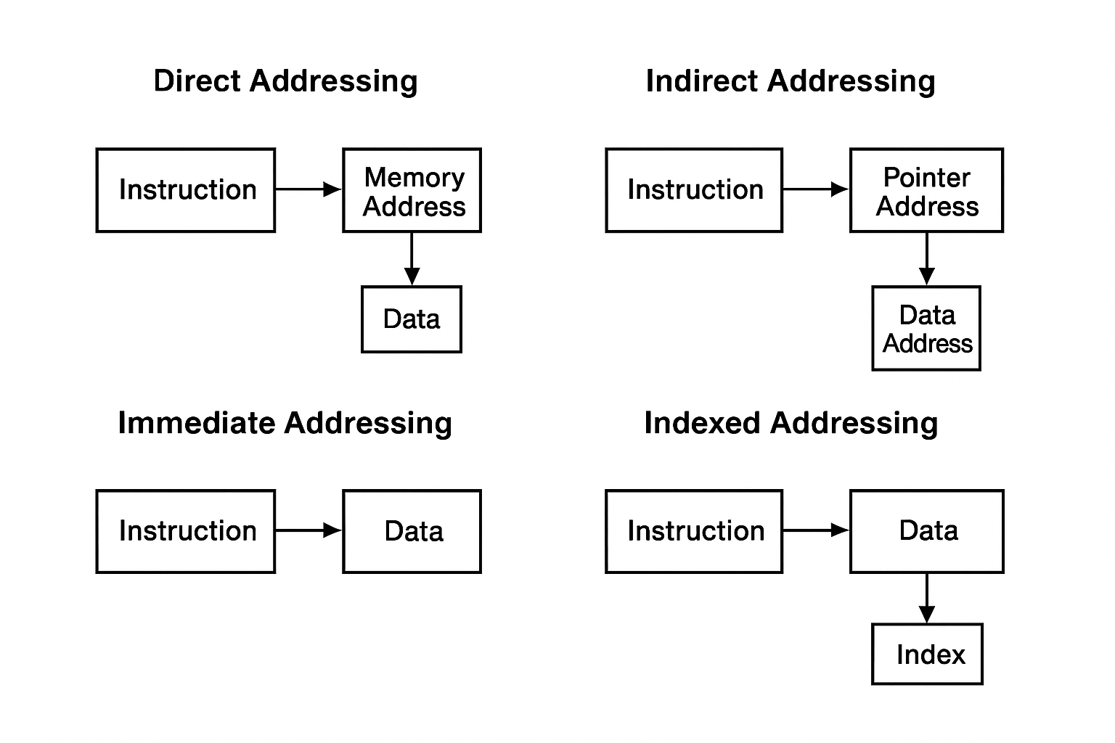
Addressing Methods

Importance of Internal Memory, External Memory, Virtual Memory, and Cache Memory
Memory is a crucial part of computer systems that is responsible for holding data, programs, and instructions. A computer cannot complete any meaningful task without memory. There are various types of memory that serve a specific purpose for the computer's architecture. The two most important types in computer memory includes internal memory, external memory, virtual memory, and cache memory. Internal memory refers to the portions of memory that are also classified as storage of the computer system. The internal memory refers to the storage of the computer system. The two most common types of internal memory includes random access memory (RAM) and read-only memory (ROM). RAM is a temporary storage; it is volatile memory, which means that it holds the data, programs, and instructions that are currently being used by the central processing unit (CPU) but is lost with the power is turned off. The amount of RAM in a system is a factor in how many things a computer can run at one time. For example, a computer with 16 GB of RAM is able to run many more applications more efficiently than a computer with 4 GB of RAM. ROM is non-volatile memory, which means it permanently stores the instructions and programs that are essential for the user to perform useful functions on the computer. An example of ROM is the bios, which provides the computer with the instructions to initialize a hardware device each time the computer is turned on. External memory is characterized as storage components that are separate from the primary computer, which are used to store data over extended periods. Examples are hard disk drives (HDDs), solid-state disk drives (SSDs), USB flash drives, and optical discs. External memory offers significant storage and keeps data safe while the computer is off or when using different systems. Devices in this category offer ample storage for files, backups, and software installation. For example, a 1 terabyte (1 TB) external hard drive can store thousands of videos and documents, and many applications. External memory is slower than internal memory, but it is the primary means of permanent storage and retrieval of data in the computer. Virtual memory is a memory management method that leverages the hard drive as supplementary RAM. When there is no physical memory available, inactive data in RAM is moved to a designated area on the hard drive known as swap space or a page file. This gives users the possibility of running more apps simultaneously, even if physical RAM is limited. For example, when having several web browser windows opened, virtual memory will temporarily store inactive tabs on the hard disk, thus freeing up memory space in physical RAM. In general, virtual memory is slower than real RAM, but it prevents system crashes and allows larger programs to run without any issues. The cache is a small and very fast memory area interposed between the CPU and main memory. It stores frequently accessed data and instructions to save time spent by the CPU waiting for data from the static RAM. Cache is indeed very fast and has a small capacity. Most modern processors use multi-level cache, with Level 1 memory-the fastest and with the smallest size, the Level 2 memory, correspondingly larger in size and slower, and large Level 3 memory shared between processor cores. For example, an Intel Core i7 has up to 12 MB of memory, which significantly enhances the calculation of even more complex formulas
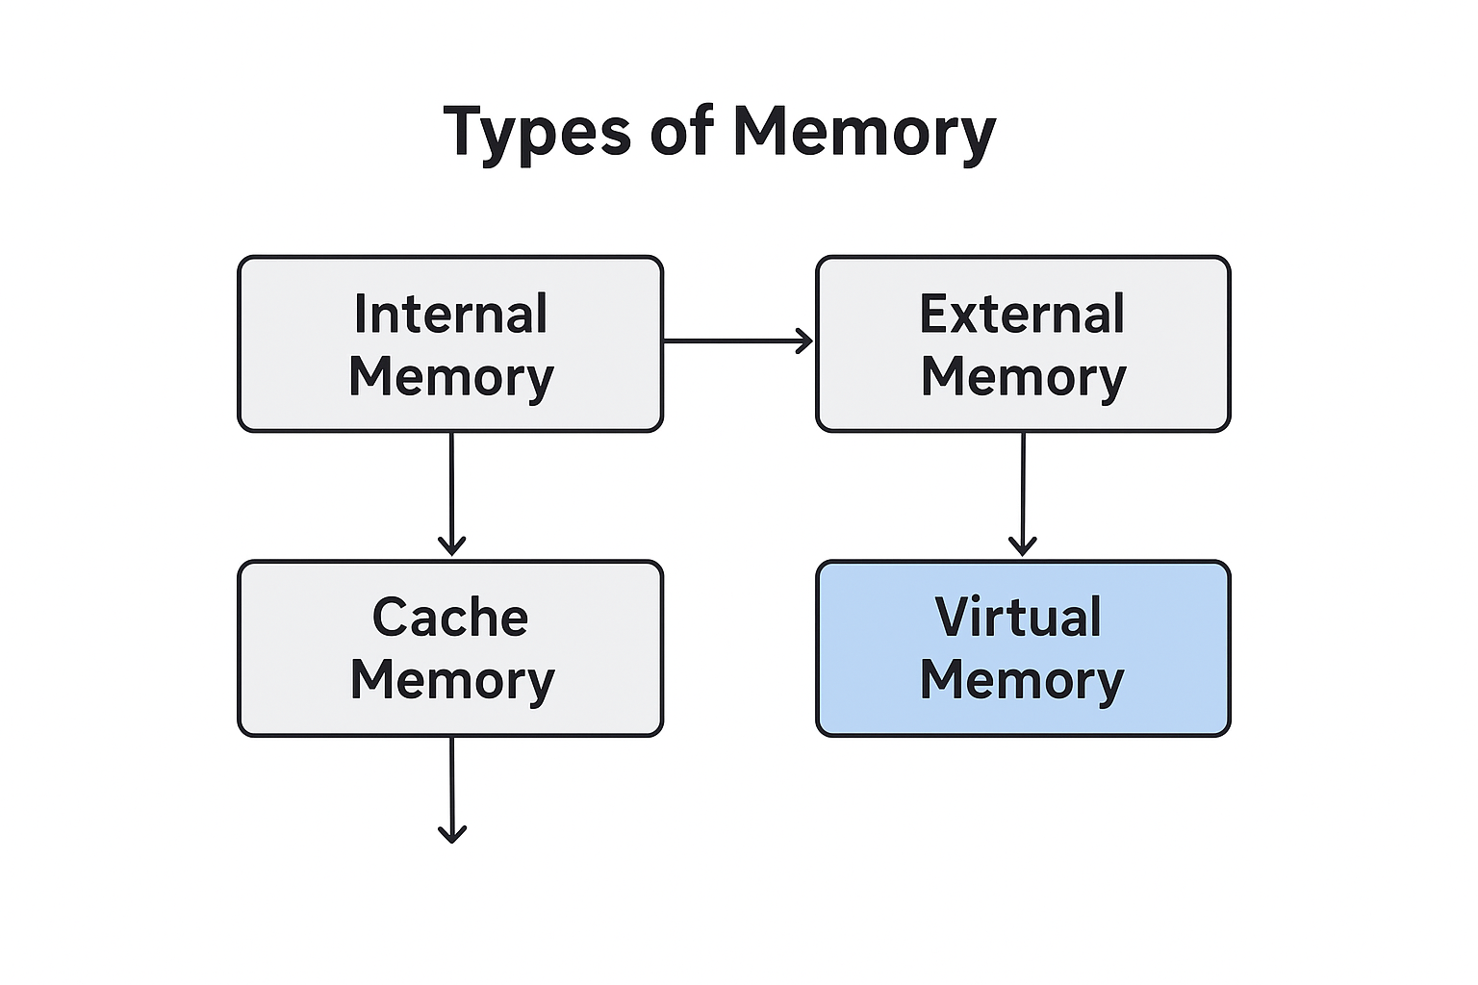
Memory Types

Conclusion
At its core, computer architecture describes how digital systems work, evolve, and perform. Today's digital systems have evolved and developed from the earliest computers that utilized vacuum tubes, which laid the foundation of microprocessor devices featured in modern computers. Each generation began with the previous one and eventually produced smaller, faster, smarter technology. When we think of hardware, we think of physical components, or logic circuits, and gates, being the true building blocks of all computing systems. Logic circuits are used to implement and perform all processes of computer operation including arithmetic, logical, and computer decisions. Eventually, data and instruction processing will take place wherever you’ve set up your system to access read, write, or execute, known as methods of addressing, and this can affect processes with efficiency. Memory can also be described as internal, external, virtual, and cache memory - but in any case, memory all work in unison to read, write, retrieve, and process information efficiently. These components collectively combine to provide the foundation for all computing systems. A better understanding not only enhances reader's appreciation of actual computing technology but it will also build the grounding for new design and improvement of technology in their future

References

Floyd, T. L. (2018). Digital Fundamentals (11th ed.). Pearson Education.

Mano, M. M. (2017). Computer System Architecture (3rd ed.). Pearson Education.

Mano, M. M., & Ciletti, M. D. (2017). Digital Design: With an Introduction to the Verilog HDL, VHDL, and SystemVerilog (6th ed.). Pearson Education.

Tanenbaum, A. S., & Austin, T. (2013). Structured Computer Organization (6th ed.). Pearson.

Stallings, W. (2019). Computer Organization and Architecture: Designing for Performance (11th ed.). Pearson Education.

Patterson, D. A., & Hennessy, J. L. (2017). Computer Architecture: A Quantitative Approach (6th ed.). Morgan Kaufmann.

Hamacher, C. V., Vranesic, Z. G., & Zaky, S. G. (2012). Computer Organization and Embedded Systems (6th ed.). McGraw-Hill Education.

Null, L., & Lobur, J. (2018). The Essentials of Computer Organization and Architecture (5th ed.). Jones & Bartlett Learning.

Morley, D. (2021). Understanding Computers: Today and Tomorrow (17th ed.). Cengage Learning.

Smailagic, A., & Siewiorek, D. (2020). Computer Architecture: Concepts and Evolution. Carnegie Mellon University Press.

Stallings, W. (2020). Computer Security: Principles and Practice (5th ed.). Pearson.

McGraw-Hill. (2022). Fundamentals of Computer Architecture. Retrieved from https://www.mheducation.com/

IBM. (2024). The Evolution of Computing Systems: From Mainframes to AI. Retrieved from https://www.ibm.com/history

Intel Corporation. (2023). Understanding Processor Architecture and Cache Design. Retrieved from https://www.intel.com/

AMD. (2023). AMD Architecture Overview. Retrieved from https://www.amd.com/en/technologies

Microsoft. (2024). How Virtual Memory Works. Retrieved from https://learn.microsoft.com/en-us/windows/

GeeksforGeeks. (2024). Addressing Modes in Computer Architecture. Retrieved from https://www.geeksforgeeks.org/addressing-modes/

Tutorials Point. (2024). Logic Gates and Boolean Algebra. Retrieved from https://www.tutorialspoint.com/digital_electronics/digital_electronics_logic_gates.htm

Computer Hope. (2024). Computer Memory Overview. Retrieved from https://www.computerhope.com/jargon/m/memory.htm

Britannica. (2024). Computer: History of Computing. Retrieved from https://www.britannica.com/technology/computer

IEEE Computer Society. (2020). IEEE Transactions on Computers. Retrieved from https://ieeexplore.ieee.org/xpl/RecentIssue.jsp?punumber=12

Oracle. (2023). Computer Architecture Basics: CPU, Memory, and Storage. Retrieved from https://www.oracle.com/

TechTarget. (2023). What is Cache Memory and How Does It Work? Retrieved from https://www.techtarget.com/whatis/

Khan Academy. (2024). Introduction to Computer Architecture. Retrieved from https://www.khanacademy.org/

National Institute of Standards and Technology (NIST). (2023). Fundamentals of Computer Systems. Retrieved from https://www.nist.gov/

OpenLearn. (2023). The Basics of Digital Logic and Computer Architecture. The Open University. Retrieved from https://www.open.edu/openlearn/

MIT OpenCourseWare. (2024). Introduction to Computer Architecture. Retrieved from https://ocw.mit.edu/

CS50 Harvard. (2023). Digital Logic and Computer Hardware. Harvard University. Retrieved from https://cs50.harvard.edu/

Techopedia. (2024). Virtual Memory Explained. Retrieved from https://www.techopedia.com/definition/3929/virtual-memory

Microchip Technology Inc. (2024). Microprocessor and Embedded Architecture Fundamentals. Retrieved from https://www.microchip.com/

